DAY 14 - CREDENTIAL SECURITY ASSESSMENT
Project: Local Lab Analysis
Target Machine: Metasploitable 2 (192.168.56.102)
Analyst: Urooj

1. PASSWORD SECURITY (Storage Analysis)

Command Used:
sudo cat /etc/passwd

Observation:
- /etc/passwd file shows 'x' in password field for all users. This means passwords are not stored in plain text in this world-readable file. This is a GOOD practice.
- The actual password hashes are stored in /etc/shadow which is only readable by root.
- This follows the principle of secure credential storage.

[ 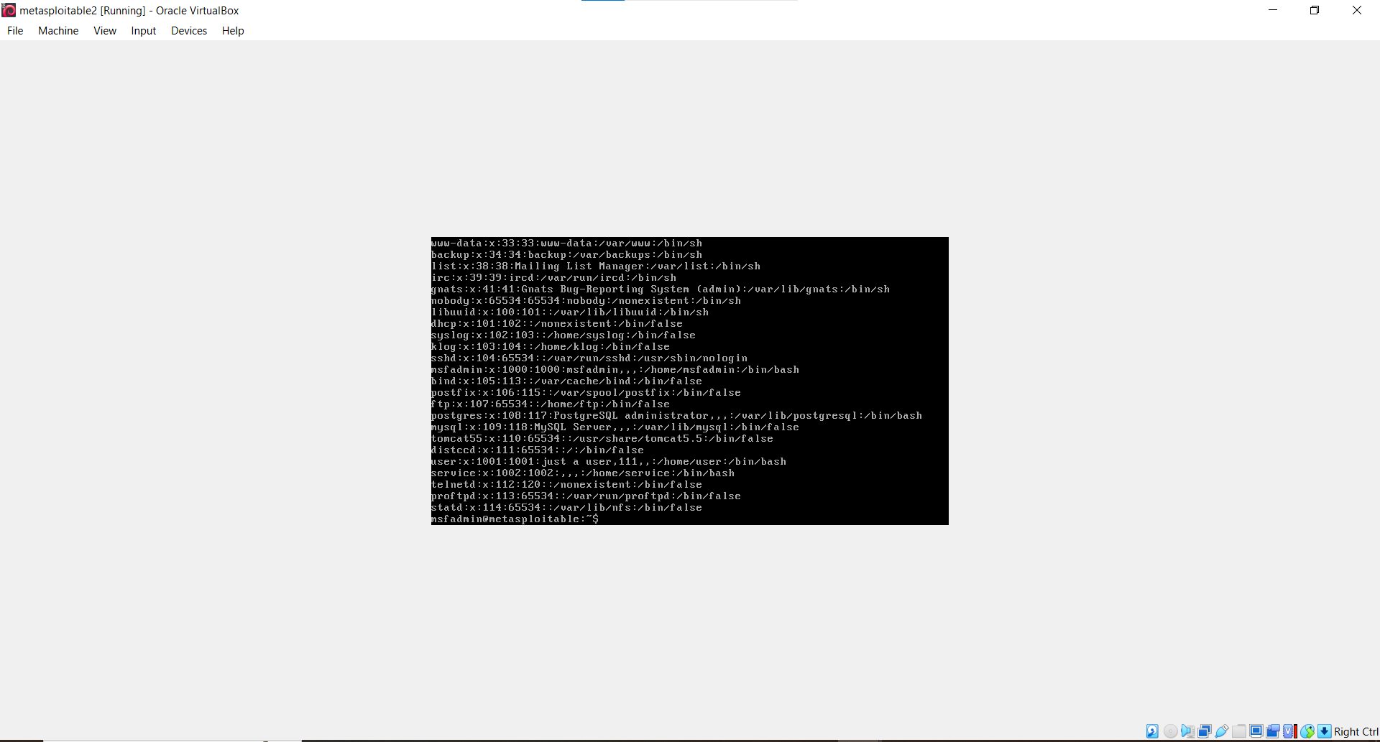/etc/passwd ]

2. HASHING CONCEPTS (Weak Hashing Found)

Command Used:
sudo cat /etc/shadow | head -n 15

Output Sample:
root:$1$/avpfBJ1$xOzBw5UF91v./DR9E9Lid.:14747:0:99999:7:::
sys:$1$fUX6BP0t$Miyc3UpOzQJqz4s5wFD910:14742:0:99999:7:::

Analysis:
- Hash format is $1$salt$hash
- $1$ = MD5 hashing algorithm. This is a WEAK and outdated algorithm from 1990s.
- Modern secure systems use $6$ which is SHA-512.
- MD5 hashes can be easily cracked using tools like John the Ripper.
- This is a CRITICAL vulnerability.
- Concept: Hashing is one-way encryption. System never stores real password, only stores its hash.

[ 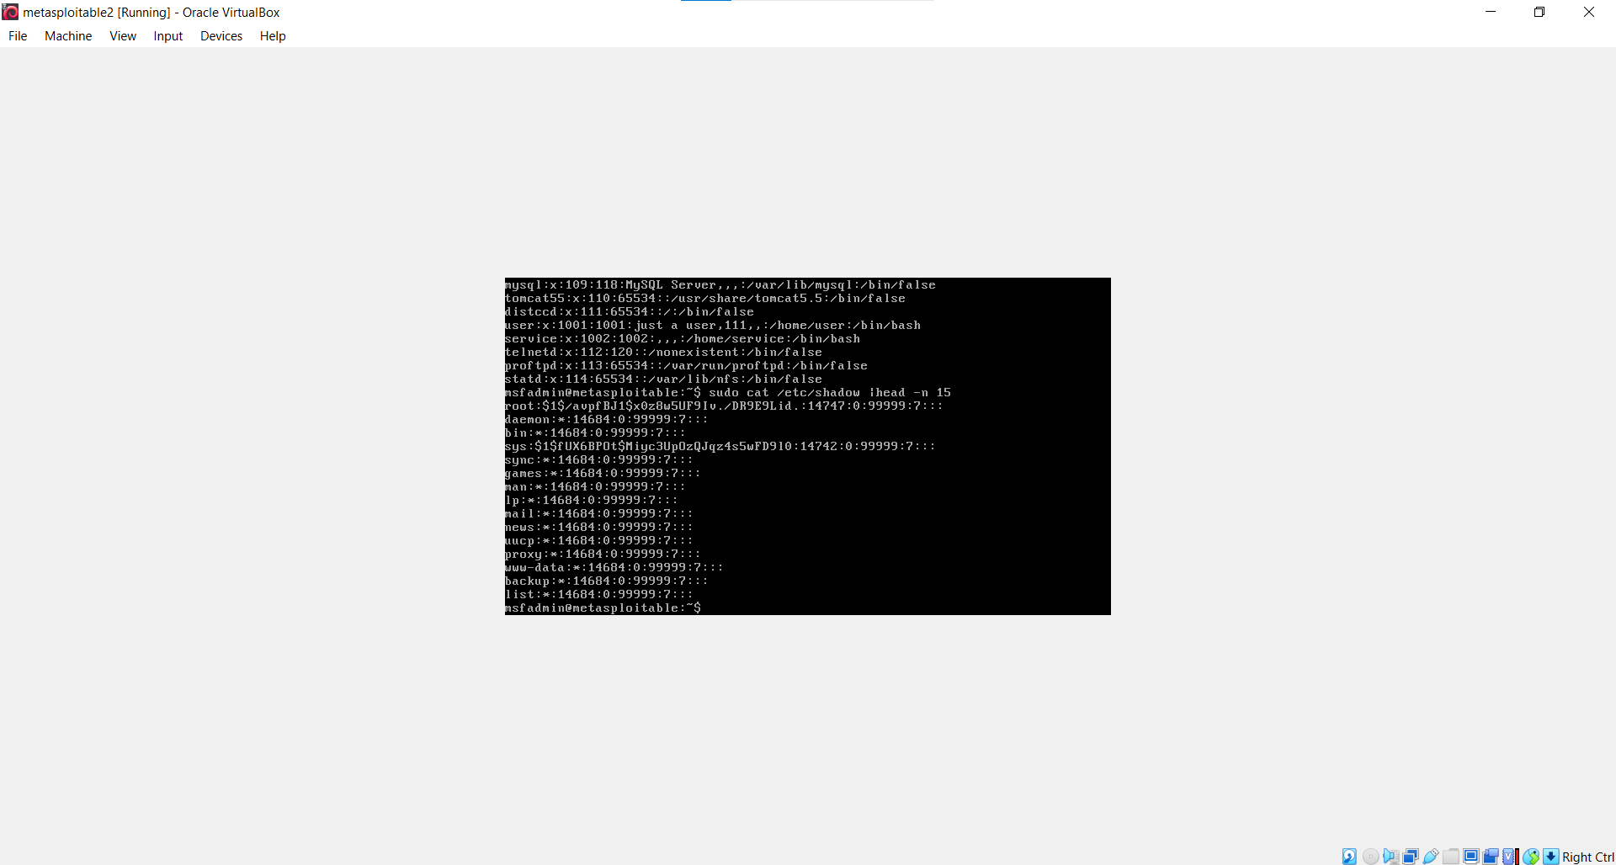: /etc/shadow Screenshot showing $1$ MD5 hash ]

3. CREDENTIAL EXPOSURE (Leakage Check)

Commands Used:
cat ~/.bash_history
grep -R -i "password" /var/www/ 2>/dev/null

Observation:
- No direct password found in bash_history in this check.
- However, Metasploitable is known for credential exposure in config files like /var/www/dvwa/config.inc.php where DB passwords are stored in plain text.
- Risk: If attacker finds such files, they get database credentials directly.

4. SECURE AUTHENTICATION (Password Policy)

Command Used:
cat /etc/login.defs | grep -i PASS

Output:
PASS_MAX_DAYS 99999
PASS_MIN_DAYS 0
PASS_WARN_AGE 7

Analysis:
- PASS_MAX_DAYS 99999 means password never expires (99999 days = 273 years). This violates secure authentication policy. Best practice is 60-90 days.
- PASS_MIN_DAYS 0 means user can change password immediately again.
- The file also mentions "MD5-based passwords" in comments, confirming weak hashing is intentionally configured.
- No strong password complexity enforcement found.

[ 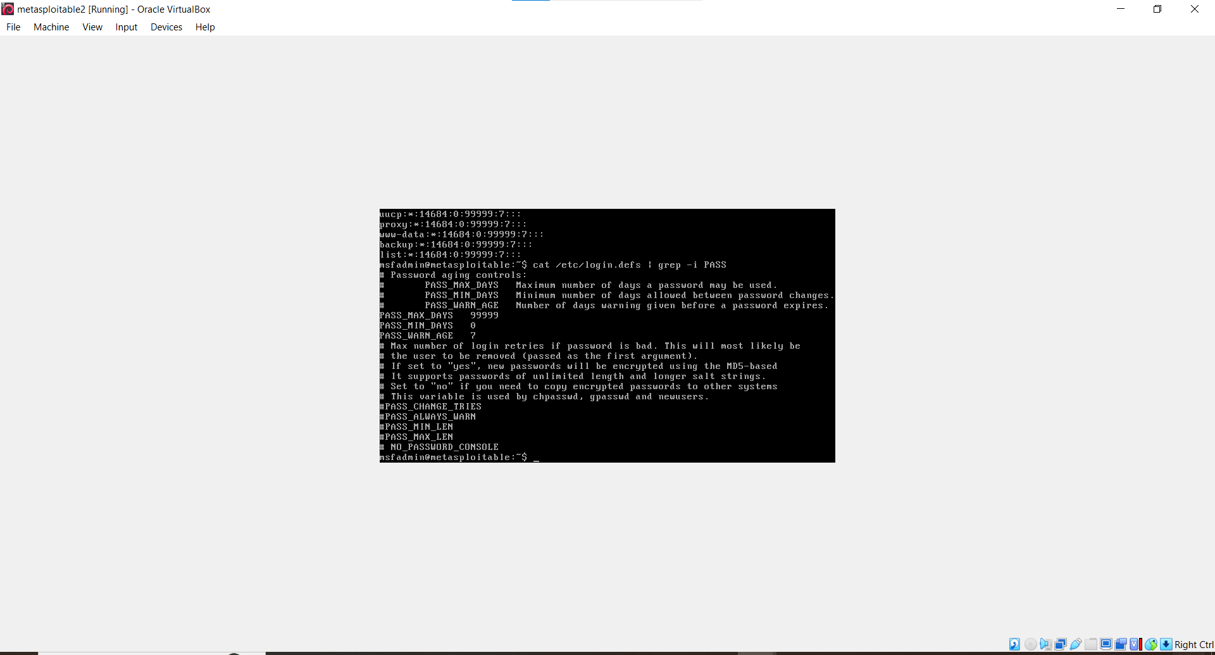: /etc/login.defs Screenshot showing PASS_MAX_DAYS 99999 ]

5. RISK SUMMARY & RECOMMENDATIONS

Risk Level: HIGH

Vulnerabilities Found:
1. Weak Hashing Algorithm (MD5 instead of SHA-512)
2. Password Never Expires Policy (99999 days)
3. Potential Credential Exposure in Web Files

Recommendations:
1. Upgrade hashing to SHA-512 ($6$) by editing /etc/login.defs and /etc/pam.d/common-password
2. Set PASS_MAX_DAYS to 90, PASS_MIN_DAYS to 1, PASS_MIN_LEN to 8
3. Implement password complexity
4. Remove hardcoded plain-text passwords from config files
5. Enable multi-factor authentication (MFA)

CONCLUSION

The system stores passwords securely in /etc/shadow, but the hashing concept used is outdated (MD5). Authentication policy is extremely weak with passwords that never expire. System is vulnerable to offline hash cracking and credential reuse attacks.

